Chapter 9, Solution 12.
Let X = 4∠40° and Y = 20∠–30°. Evaluate the following quantities and express your results in polar form.

(X + Y)/X*
(X - Y)*
(X + Y)/X

X = 3.064+j2.571; Y = 17.321–j10

(a) (X + Y)X* = 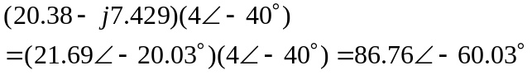
= 86.76∠–60.03˚

(b) (X – Y)* = (–14.257+j12.571)* = 19.41∠–139.63˚

(c) (X + Y)/X = (21.69∠–20.03˚)/(4∠40˚) = 5.422∠–60.03˚

